Chapter 6: Multiple Regression I

6.1 Multiple regression models

3-D Algebra Review

Plot Y = 1 + 2x₁ - 3x₂

Y | X₁ | X₂
1 | 0 | 0
3 | 1 | 0
-2 | 0 | 1
0 | 1 | 1

The connected (Y, X₁, X₂) triples form a plane:
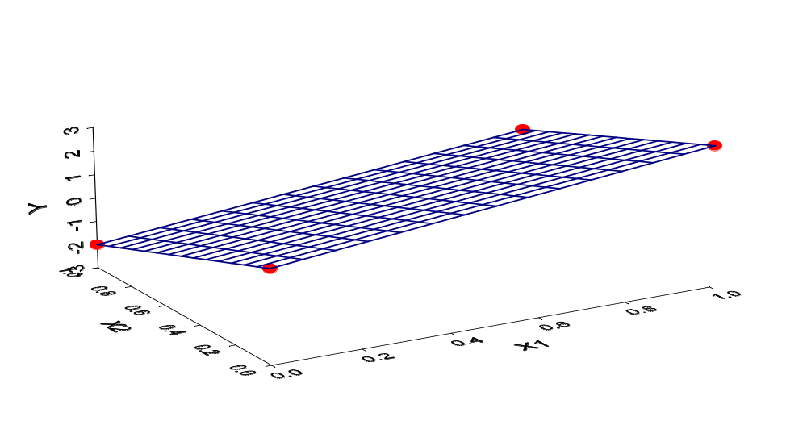
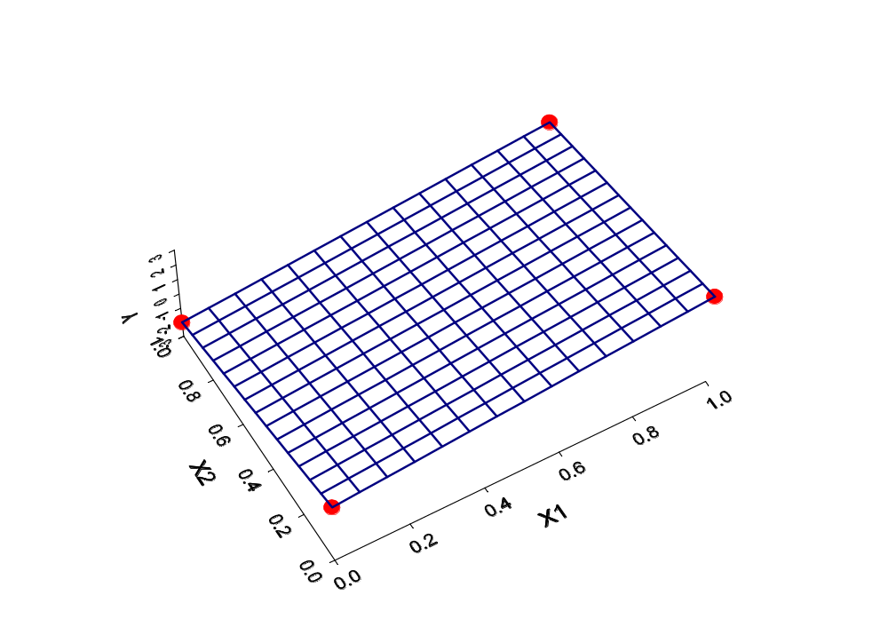
From above:

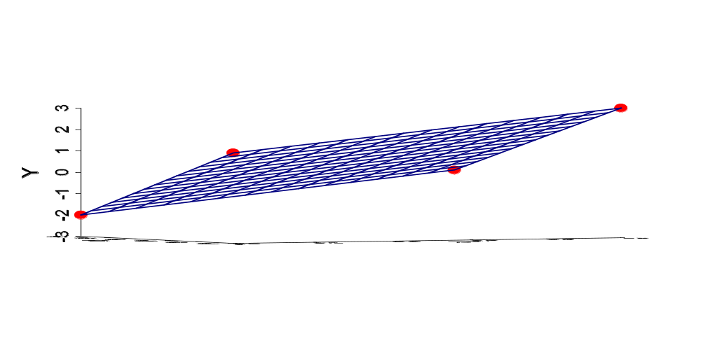From the X₁ and X₂ plane level (at Y=-3):
Simple linear regression
One predictor variable is used to estimate one dependent variable.
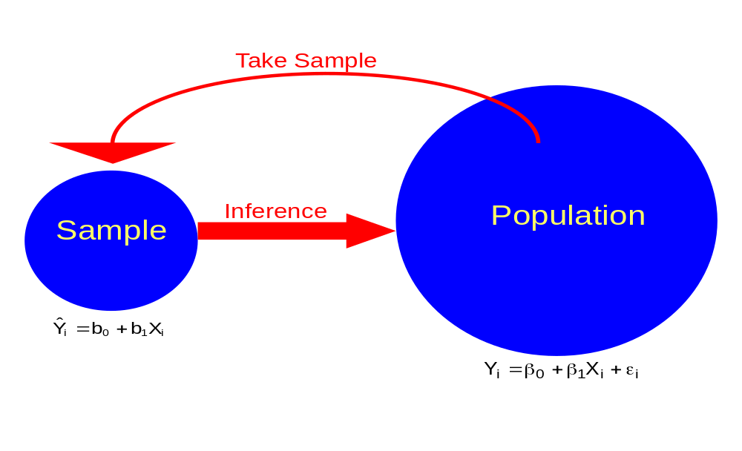

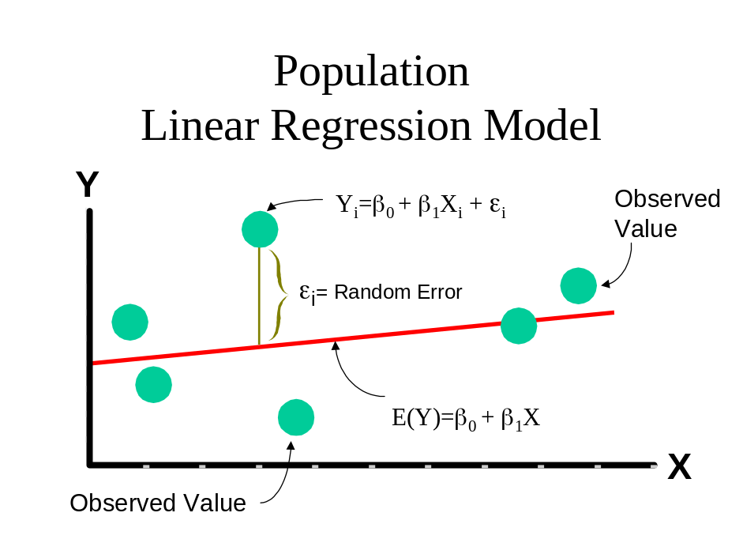

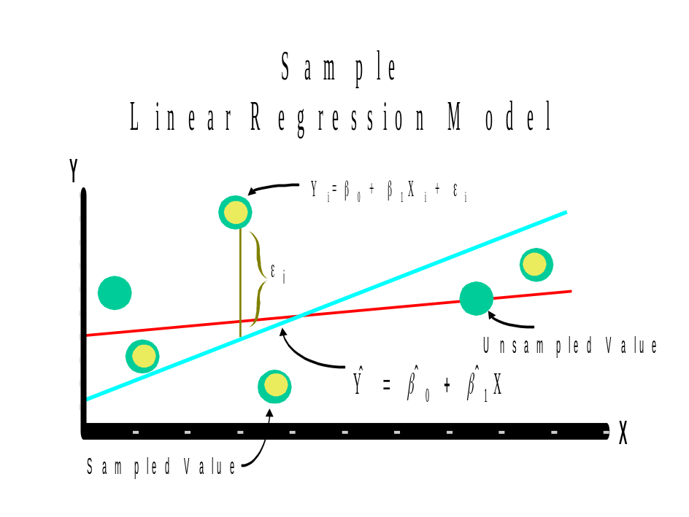

Multiple linear regression
Two or more predictor variables are used to estimate 1 dependent variable.

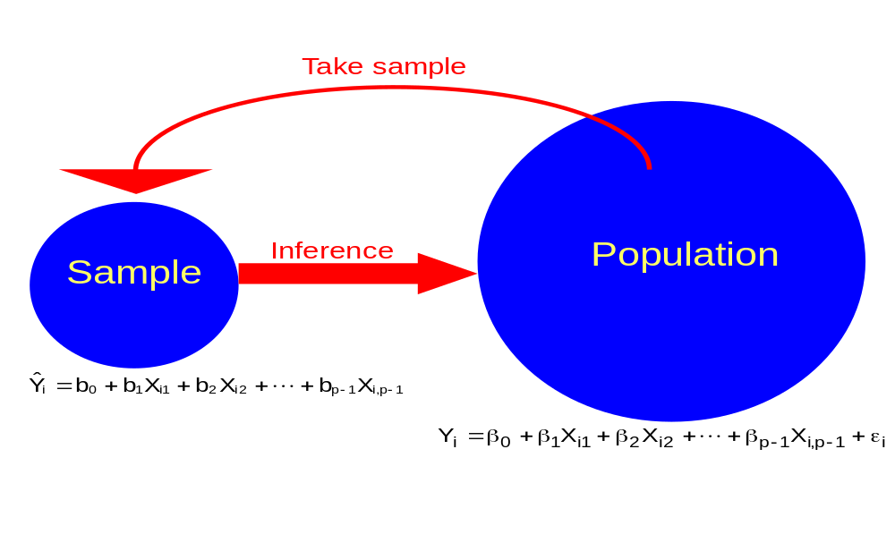
Notes:
- ε_{i}~independent N(0,σ²)
- β₀, β₁, …,β_{p-1} are parameters with corresponding estimates of b₀, b₁, …, b_{p-1}
- X_{i1},…,X_{i,p-1} are known constants (see Section 2.11 when the X’s are random variables – mostly everything stays the same)
- The second subscript on X_{ik} denotes the k^{th} predictor variable.
- i=1,…n

Now suppose there are only 2 predictor variables:

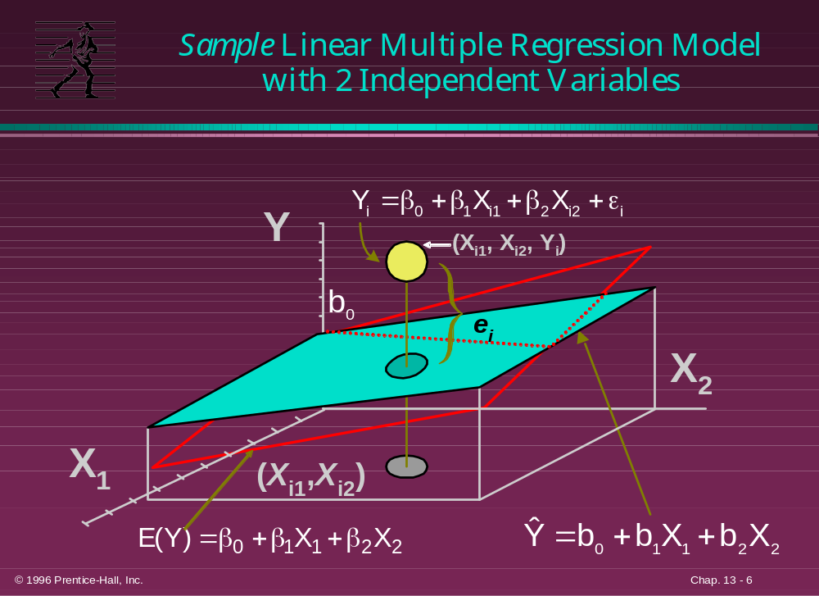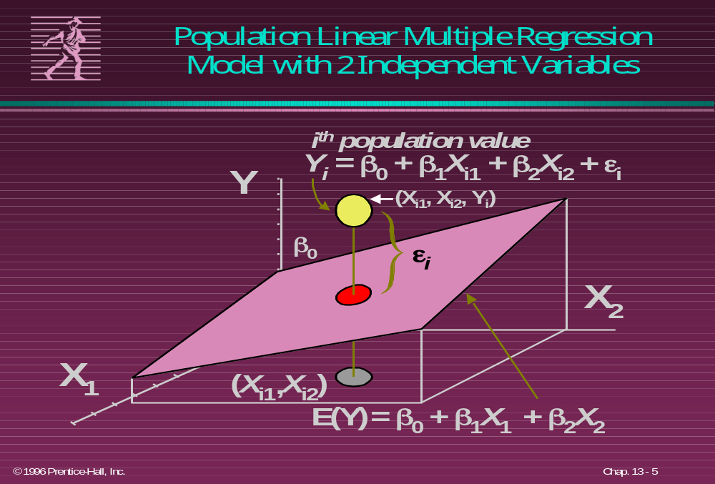
Notes:
- Often when we want to just refer to the first, second,… predictor variables, the i subscript is dropped from X_{ij}. Thus, predictor variable #1 is X₁, predictor variable #2 is X₂,…
- Y_{i}=β₀+β₁X_{i1}+…+β_{p-1}X_{i,p-1}+ε_{i} is called a “first-order” model since the model is linear in the predictor (independent, explanatory) variables.
- There are p – 1 predictor variables and p β parameters.
- The coefficient on the k^{th} predictor variable is β_{k}. This measures the effect X_{k} has on Y with the remaining variables in the model held constant.
- Qualitative variables (variables not measured on a numerical scale) can be used in the multiple regression model. For example, let X_{ik}=1 to denote female, X_{ik}=0 to denote male. More will be done with qualitative variables in Chapter 8.
- Polynomial regression models contain higher than first order terms in the model. For example, 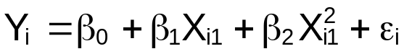. More will be done with polynomial regression models in Chapter 7.
- Transformed variables can be used just as in simple linear regression. For example, log(Y_{i}) can be taken to be the response variable. More will be done with transformed variables in Chapter 7.
- If the effect of one predictor variable on the response variable depends on another predictor variable, interactions between predictor variables can be included in the multiple regression model. For example, . More will be done with interactions in Chapter 7.
- The word “linear” in multiple linear regression is in reference to the parameters. For example, 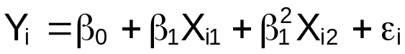 is not a multiple LINEAR regression model.

6.2 General linear regression model in matrix terms

Note that the Y_{i}=β₀+β₁X_{i1}+…+β_{p-1}X_{i,p-1}+ε_{i} for i=1,…,n can be written as:

Y₁=β₀+β₁X₁₁+…+β_{p-1}X_{1,p-1}+ε₁
Y₂=β₀+β₁X₂₁+…+β_{p-1}X_{2,p-1}+ε₂
Y₃=β₀+β₁X₃₁+…+β_{p-1}X_{3,p-1}+ε₃

Y_{n}=β₀+β₁X_{n1}+…+β_{p-1}X_{n,p-1}+ε_{n}

Let
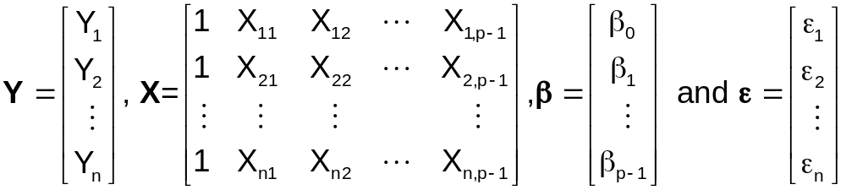
Then Y = Xβ + ε, which is

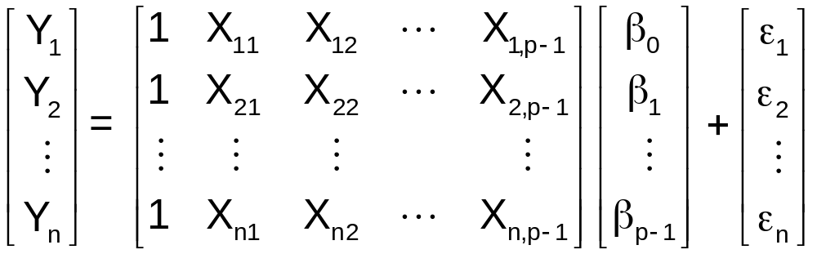

Remember that ε has mean 0 and covariance matrix
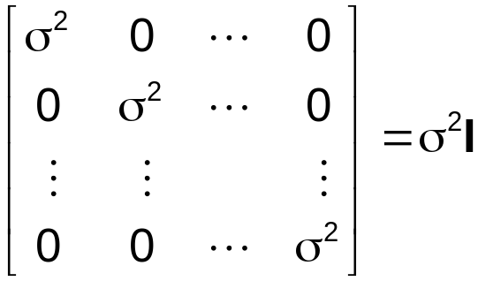
since the ε_{i} are independent.

Note that E(Y) = E(Xβ + ε) = E(Xβ) = Xβ since E(ε) = 0

Question: What is Cov(Y)?

6.3 Estimation of regression coefficients (β_{j}’s)

Parameter estimates are found using the least squares method.

From Chapter 1: The least squares method tries to find the b₀ and b₁ such that SSE = Σ(Y-)² = Σ(residual)² is minimized. Formulas for b₀ and b₁ are derived using calculus.

For multiple regression, the least squares method minimizes SSE = Σ(Y-)² again; however, is now

As shown in Section 5.10, the least squares estimators are 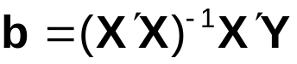. This holds true for multiple regression with
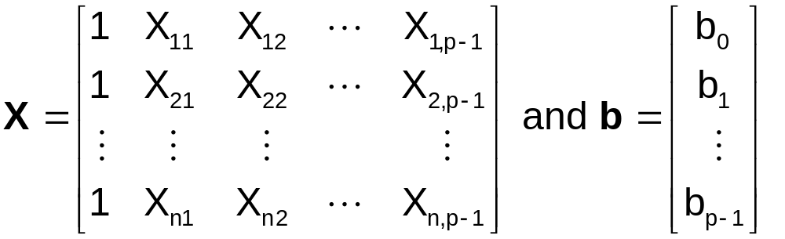

Properties of the least squares estimators in simple linear regression (such as: unbiased estimators and minimum variance among unbiased estimators) hold true for multiple linear regression.

6.4 Fitted values and residuals

Let 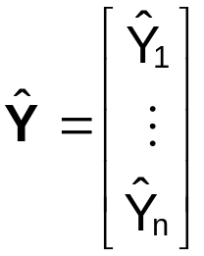. Then  since

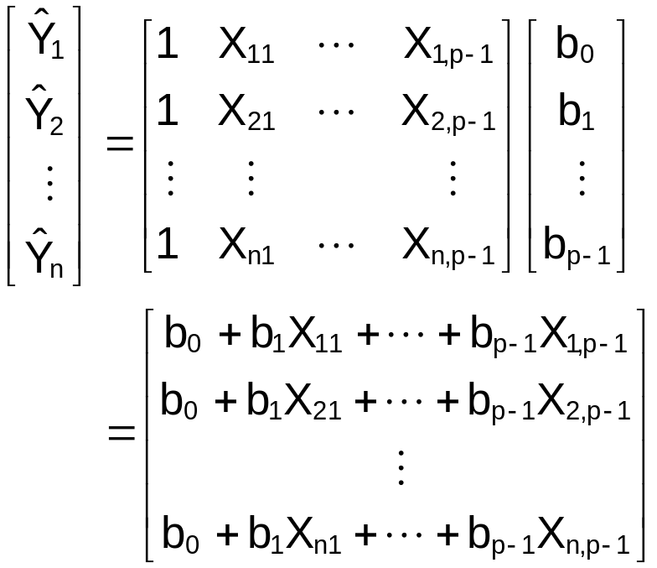

Also,
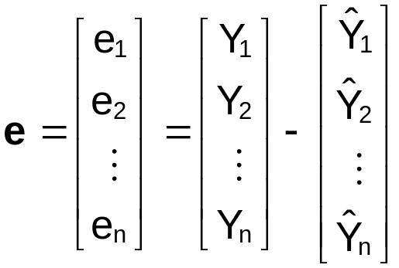

Hat matrix:  where H=X(X′X)⁻¹X′ is the hat matrix

We will use this in Chapter 10 to measure the influence of observations on the estimated regression line.

Covariance matrix of the residuals:
Cov(e) = σ²(I-H) and 